WINDOWS FUNDAMENTALS 1

AIM:

To complete and explore the tasks in windows fundamentals 1.

PROCEDURE:

Complete the tasks as per the instructions given in the respective tasks.

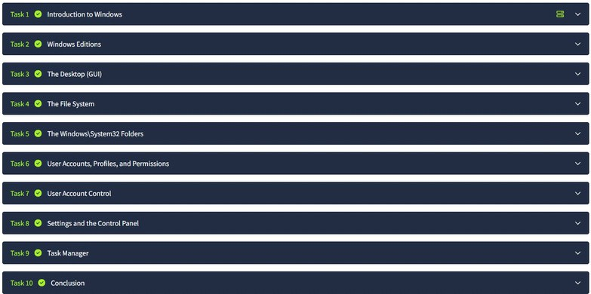

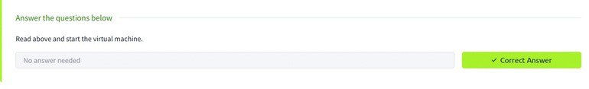1.

2,

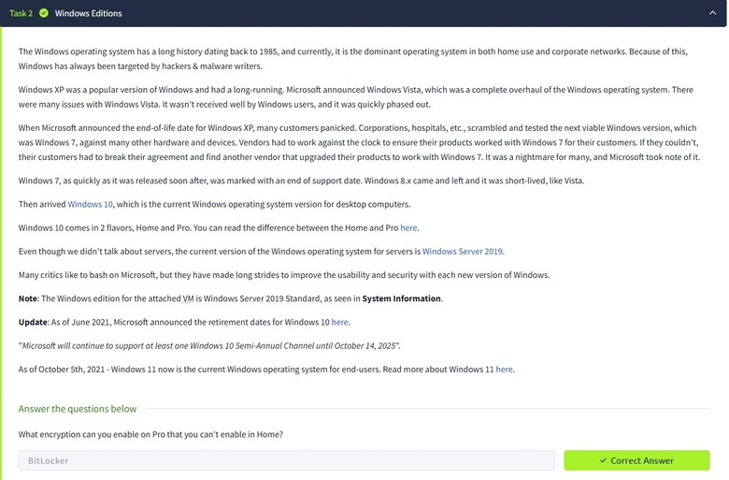

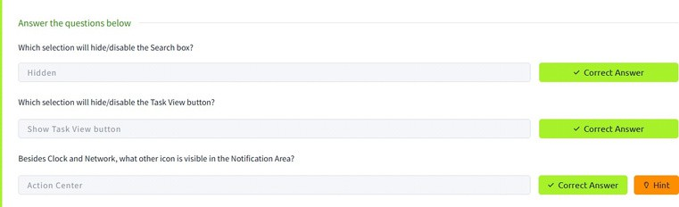3.

4.

5.



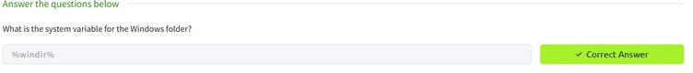

6.

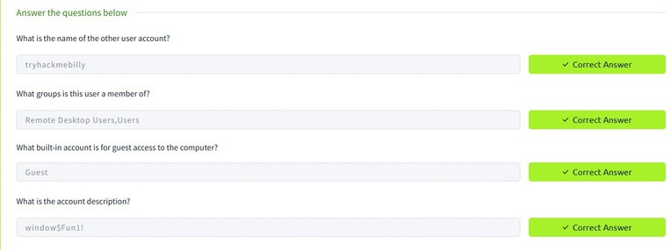

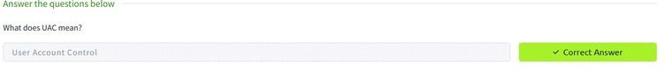7.

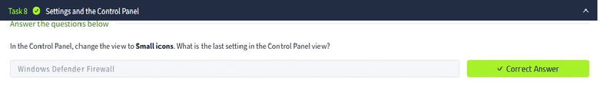8.

9.



10.

RESULT:

The tasks in Windows fundamentals 1 has been completed successfully.